[ Insert official UPAEP logo ]
UPAEP · Decanato de Ingenierías
EVIDENCE — SPR-T2
Sprint Review preparation and evidence compilation
SmartGreenAI: Cilantro Crop

1. Task information
Task ID | SPR-T2
User Story | Sprint-level task
Sprint | Sprint 3 (2026-10-12 – 2026-10-30)
Week | Week 3
Responsible | Jorge Velez Delgado + Alexis Enrique Valle Parra
Peer reviewer | Whole team
Planned / actual hours | Sprint-level task (not estimated in hours)
Completed on | October 29, 2026
Status | Done

2. Task description
Check that every task has its evidence file, update the board and burndown, prepare the demo script and the Sprint 3 summary for the Review.

3. Completion conditions
✓ Condition 1: Evidence of every task is in the Sprint 3 folder.
How it was verified: Every task of Sprint 3 has its evidence file in evidence/Sprint 3/Evidence/<User Story>/ (42 documents).
Sprint 3 evidence index
Task | Title | Responsible | Evidence file | Attachments | Status
US11-T1 | Design the alert engine and alert data model | Jorge Velez Delgado | US-11/US11-T1_Design_Alert_Engine_Alert_Data.docx | 6 | collected
US11-T4 | Implement alert evaluation on measurement ingestion | Jorge Velez Delgado | US-11/US11-T4_Implement_Alert_Evaluation_Measurement_Ingestion.docx | 11 | collected
US11-T5 | Show active alerts to the producer | Jorge Velez Delgado | US-11/US11-T5_Show_Active_Alerts_Producer.docx | 5 | collected
US11-T6 | Write automated unit tests for the alert engine | Jorge Velez Delgado | US-11/US11-T6_Write_Automated_Unit_Tests_Alert_Engine.docx | 1 | collected
US11-T7 | Test alert generation | Jorge Velez Delgado | US-11/US11-T7_Test_Alert_Generation.docx | 2 | collected
US11-T8 | Verify ingestion performance with alert evaluation | Jorge Velez Delgado | US-11/US11-T8_Verify_Ingestion_Performance_Alert_Evaluation.docx | 4 | collected
US11-T9 | Document the alert API and alert rules | Jorge Velez Delgado | US-11/US11-T9_Document_Alert_API_Alert_Rules.docx | 1 | collected
US12-T1 | Define severity classification rules | Carlos Ramirez Mendoza | US-12/US12-T1_Define_Severity_Classification_Rules.docx | 2 | collected
US12-T2 | Implement severity classification and display | Carlos Ramirez Mendoza | US-12/US12-T2_Implement_Severity_Classification_Display.docx | 4 | collected
US12-T3 | Write automated unit tests for the severity calculation | Carlos Ramirez Mendoza | US-12/US12-T3_Write_Automated_Unit_Tests_Severity_Calculation.docx | 1 | collected
US12-T4 | Test severity classification | Carlos Ramirez Mendoza | US-12/US12-T4_Test_Severity_Classification.docx | 2 | collected
US13-T1 | Implement the alert history endpoint | Carlos Ramirez Mendoza | US-13/US13-T1_Implement_Alert_History_Endpoint.docx | 2 | collected
US13-T3 | Build the alert history screen | Carlos Ramirez Mendoza | US-13/US13-T3_Build_Alert_History_Screen.docx | 3 | collected
US13-T4 | Test alert history | Carlos Ramirez Mendoza | US-13/US13-T4_Test_Alert_History.docx | 5 | collected
US15-T1 | Design the actuator command flow | Vicente Rocha Alfaro | US-15/US15-T1_Design_Actuator_Command_Flow.docx | 3 | collected
US15-T3 | Implement the actuator command endpoint | Vicente Rocha Alfaro | US-15/US15-T3_Implement_Actuator_Command_Endpoint.docx | 5 | collected
US15-T5 | Implement device polling and acknowledgement endpoints | Vicente Rocha Alfaro | US-15/US15-T5_Implement_Device_Polling_Acknowledgement_Endpoints.docx | 9 | collected
US15-T6 | Execute commands on the device or simulator | Vicente Rocha Alfaro | US-15/US15-T6_Execute_Commands_Device_Simulator.docx | 6 | collected
US15-T7 | Build irrigation control and mode selector | Vicente Rocha Alfaro | US-15/US15-T7_Build_Irrigation_Control_Mode_Selector.docx | 7 | collected
US15-T8 | Write automated tests for the command API | Vicente Rocha Alfaro | US-15/US15-T8_Write_Automated_Tests_Command_API.docx | 1 | collected
US15-T9 | Test manual irrigation | Vicente Rocha Alfaro | US-15/US15-T9_Test_Manual_Irrigation.docx | 4 | collected
US15-T10 | Document the actuator command API and polling protocol | Vicente Rocha Alfaro | US-15/US15-T10_Document_Actuator_Command_API_Polling_Protocol.docx | 5 | collected
US16-T1 | Define automatic irrigation rules | Oscar Abraham Talavera Nava | US-16/US16-T1_Define_Automatic_Irrigation_Rules.docx | 1 | collected
US16-T3 | Build the irrigation parameters screen | Oscar Abraham Talavera Nava | US-16/US16-T3_Build_Irrigation_Parameters_Screen.docx | 6 | collected
US16-T4 | Implement the automatic irrigation engine | Oscar Abraham Talavera Nava | US-16/US16-T4_Implement_Automatic_Irrigation_Engine.docx | 1 | collected
US16-T5 | Implement irrigation safety conditions | Oscar Abraham Talavera Nava | US-16/US16-T5_Implement_Irrigation_Safety_Conditions.docx | 7 | collected
US16-T6 | Run the closed-loop irrigation simulation | Oscar Abraham Talavera Nava | US-16/US16-T6_Run_Closed-Loop_Irrigation_Simulation.docx | 3 | collected
US16-T7 | Write automated unit tests for the irrigation engine | Oscar Abraham Talavera Nava | US-16/US16-T7_Write_Automated_Unit_Tests_Irrigation_Engine.docx | 1 | collected
US16-T8 | Test automatic irrigation | Oscar Abraham Talavera Nava | US-16/US16-T8_Test_Automatic_Irrigation.docx | 1 | collected
US17-T1 | Implement the actuator event log | Jorge Velez Delgado | US-17/US17-T1_Implement_Actuator_Event_Log.docx | 4 | collected
US17-T2 | Build the irrigation history screen | Carlos Ramirez Mendoza | US-17/US17-T2_Build_Irrigation_History_Screen.docx | 4 | collected
US17-T3 | Write automated tests for the event log | Carlos Ramirez Mendoza | US-17/US17-T3_Write_Automated_Tests_Event_Log.docx | 1 | collected
US17-T4 | Test event recording | Carlos Ramirez Mendoza | US-17/US17-T4_Test_Event_Recording.docx | 3 | collected
US19-T1 | Define anomaly detection methods | Alexis Enrique Valle Parra | US-19/US19-T1_Define_Anomaly_Detection_Methods.docx | 2 | collected
US19-T4 | Implement the anomaly detection service | Alexis Enrique Valle Parra | US-19/US19-T4_Implement_Anomaly_Detection_Service.docx | 7 | collected
US19-T5 | Implement the anomalies API | Alexis Enrique Valle Parra | US-19/US19-T5_Implement_Anomalies_API.docx | 3 | collected
US19-T6 | Display anomalies to the producer | Alexis Enrique Valle Parra | US-19/US19-T6_Display_Anomalies_Producer.docx | 3 | collected
US19-T7 | Write automated unit tests for the detection methods | Alexis Enrique Valle Parra | US-19/US19-T7_Write_Automated_Unit_Tests_Detection_Methods.docx | 1 | collected
US19-T8 | Test anomaly detection | Alexis Enrique Valle Parra | US-19/US19-T8_Test_Anomaly_Detection.docx | 3 | collected
US19-T9 | Tune the detection parameters | Alexis Enrique Valle Parra | US-19/US19-T9_Tune_Detection_Parameters.docx | 5 | collected
SPR-T1 | End-to-end integration test | Whole team (facilitated by Jorge) | Sprint/Sprint3_SPR-T1_End-To-End_Integration_Test.docx | 7 | collected
SPR-T2 | Sprint Review preparation and evidence compilation | Jorge Velez Delgado + Alexis Enrique Valle Parra | Sprint/Sprint3_SPR-T2_Sprint_Review_Preparation_Evidence_Compilation.docx | 0 | this document

✓ Condition 2: Board and burndown are updated.
How it was verified: Board and burndown updated by the Scrum Master after each Monday meeting (chart from the Review checkpoints).
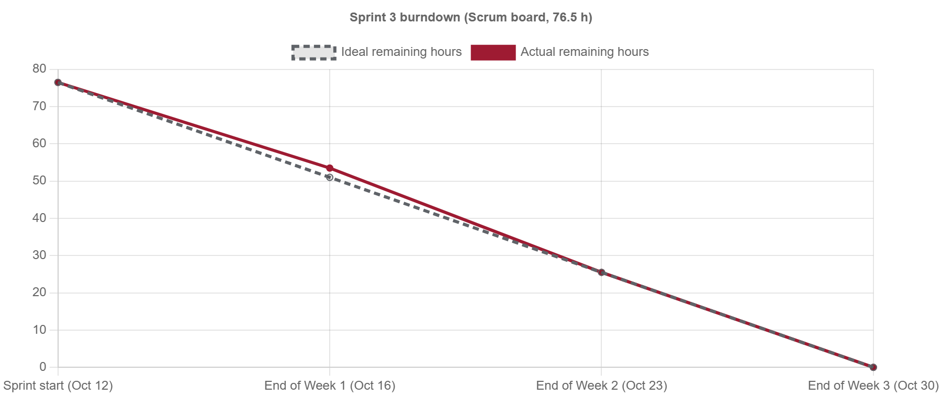
Figure SPR-T2-1. Sprint 3 burndown from the Monday checkpoints. (Sprint3_SPR-T2_Sprint_Review_Preparation_Evidence_Compilation_1.png)
✓ Condition 3: Demo script ready before the Sprint Review.
How it was verified: Demo script ready before the Review.
Demo script (attached: Sprint3_SPR-T2_Sprint_Review_Preparation_Evidence_Compilation_2.md)
1. Simulator scenario "dry": soil moisture falls below 60 %; the alert appears with its severity (US-11, US-12).
2. Alert history with filters and CSV export (US-13).
3. Manual mode: start and stop irrigation with confirmation; the pump reacts in about 5 s (US-15).
4. Automatic mode: the engine irrigates until the target and respects cooldown, tank and stale data (US-16).
5. Irrigation history with manual and automatic events and minutes per day (US-17).
6. Inject an out-of-range value and a spike: badge and plain-language list (US-19).

✓ Condition 4: Evidence: Evidence folder and demo script ready before the Review.
How it was verified: Evidence folder and demo script ready before the Review.

4. Attached files
- Sprint3_SPR-T2_Sprint_Review_Preparation_Evidence_Compilation_1.png
- Sprint3_SPR-T2_Sprint_Review_Preparation_Evidence_Compilation_2.md

5. Traceability
Related requirements | All requirements of the sprint
Implementation | docs/scrum/Sprint 3/
Verification | —

6. Sign-off
Role | Name | Date | Signature
Responsible | Jorge Velez Delgado + Alexis Enrique Valle Parra | October 29, 2026
Peer reviewer | Whole team | October 29, 2026
Product Owner acceptance | Alexis Enrique Valle Parra | October 29, 2026
Approval record: Sprint 3 Review & Delivery (October 30, 2026): "Product Owner accepted the seven user stories: all acceptance criteria met." Burndown in the Sprint 3 Burndown Reflection.

